**\*\* Integrate Email Functionality in our Project related to Learning Management System \*\***

**Candidate Importing Module**

Create an add candidate event screen which is the list of existing candidates who want to take the test.

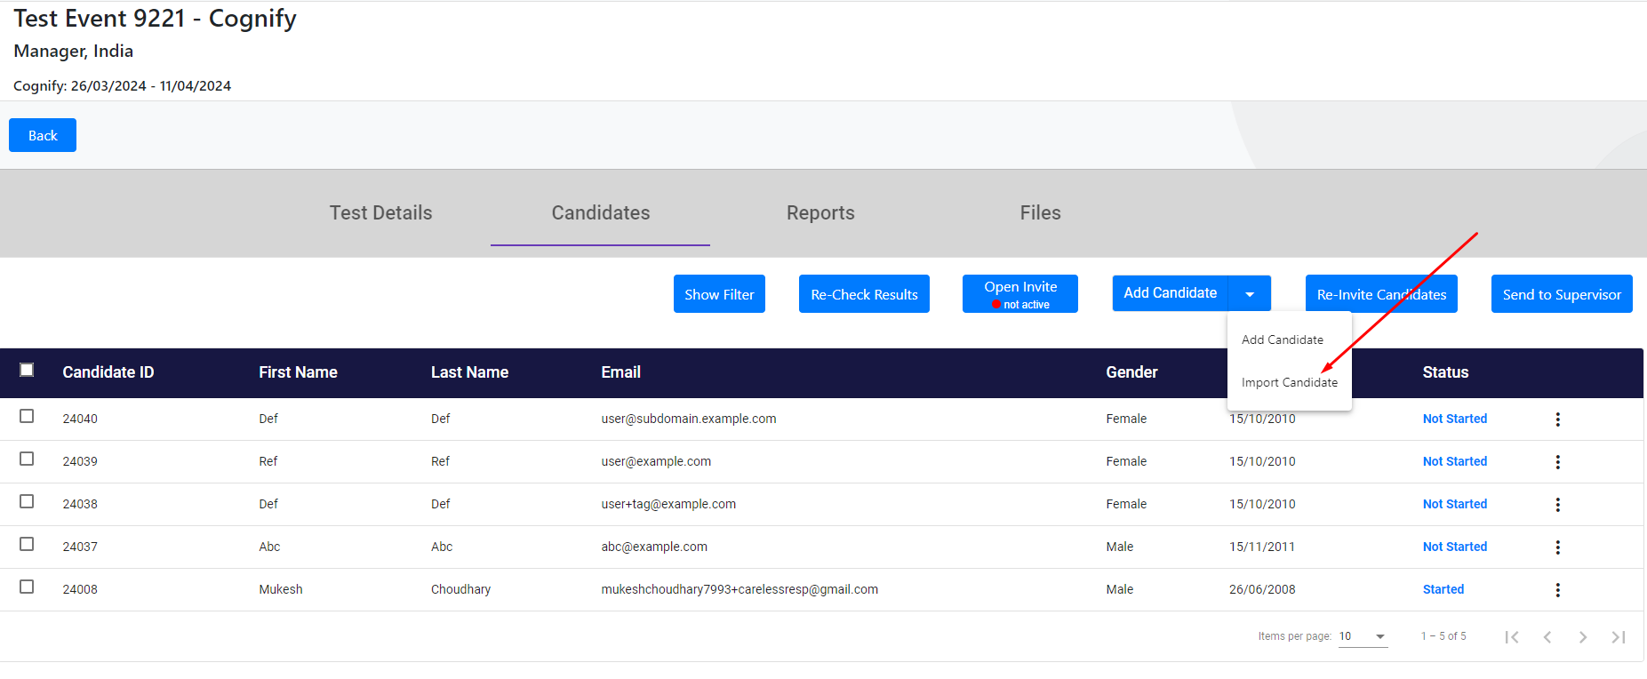

When i click on Add Candidate functionality it enable me to add a particular candidate functionality and bulk candidate addition functionality (Import Candidate)

2. When I click on Import Candidate (Bulk email sending functionality)

Popup is opened which contain sample file of candidates or import file option for choosing the necessary file containing the candidate information list with their email id’s.

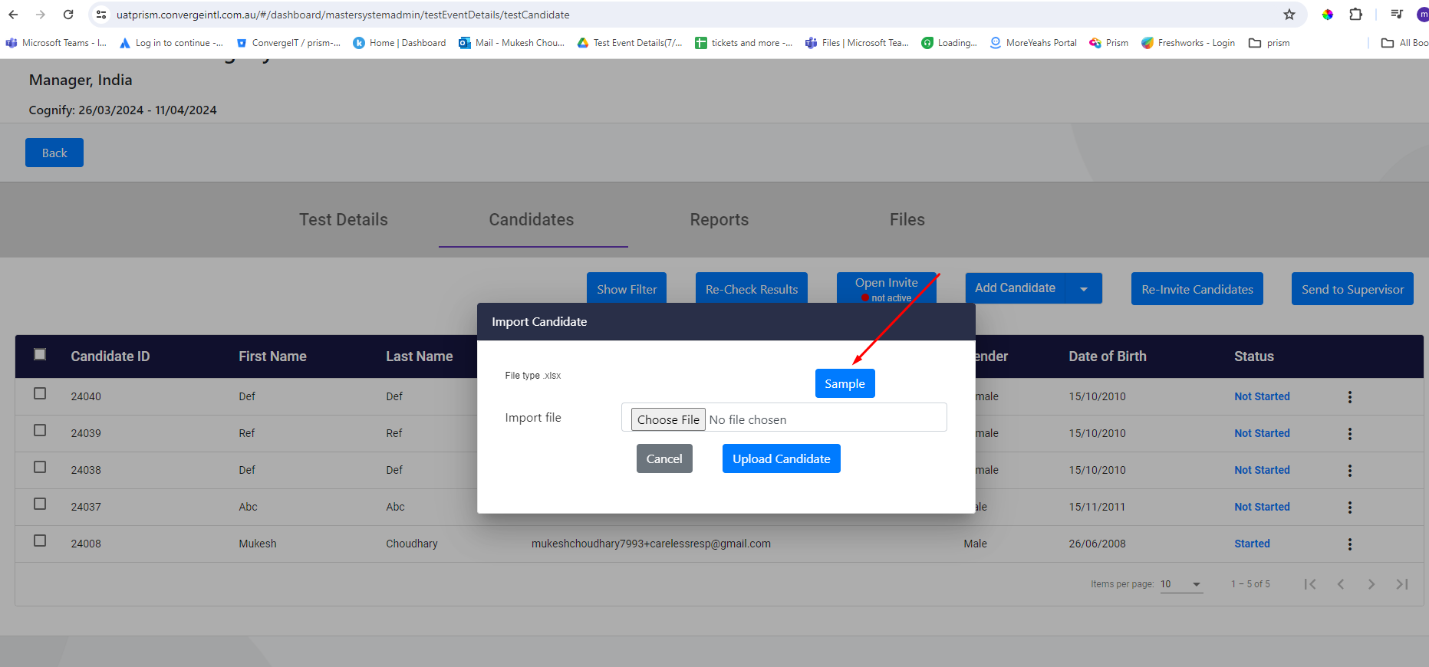

** *Here is the sample file (xlsx, csv)* **

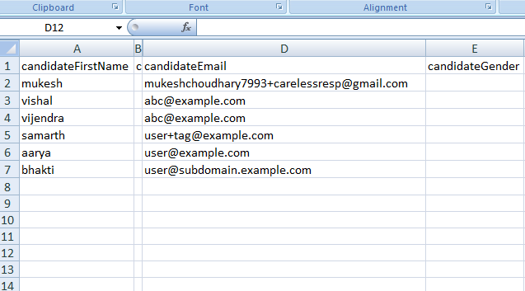

3. After adding the file. On click on Upload Candidate button.

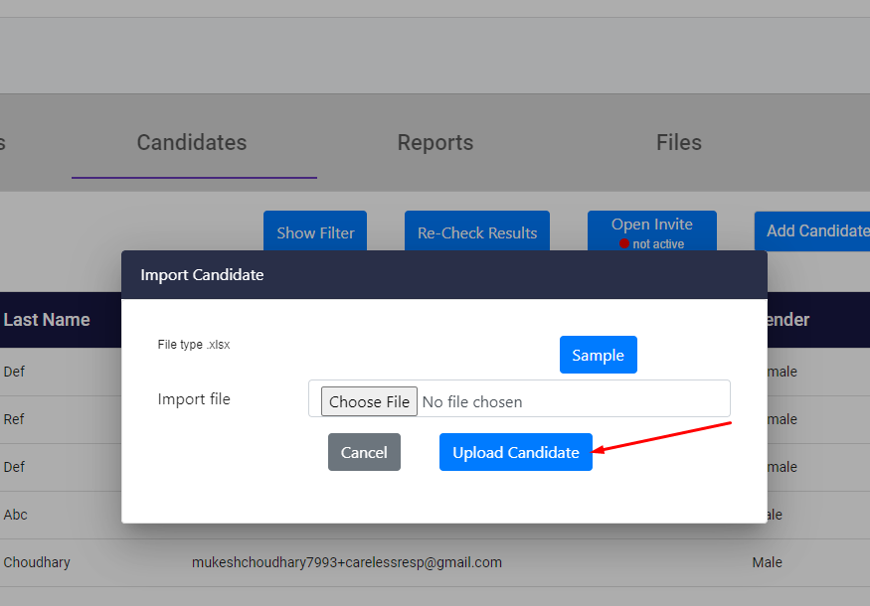

Backend Functionality reads the file and sends bulk Invitation email to all the candidates with email template and invitation link.

** ***Sample Email Template*** **

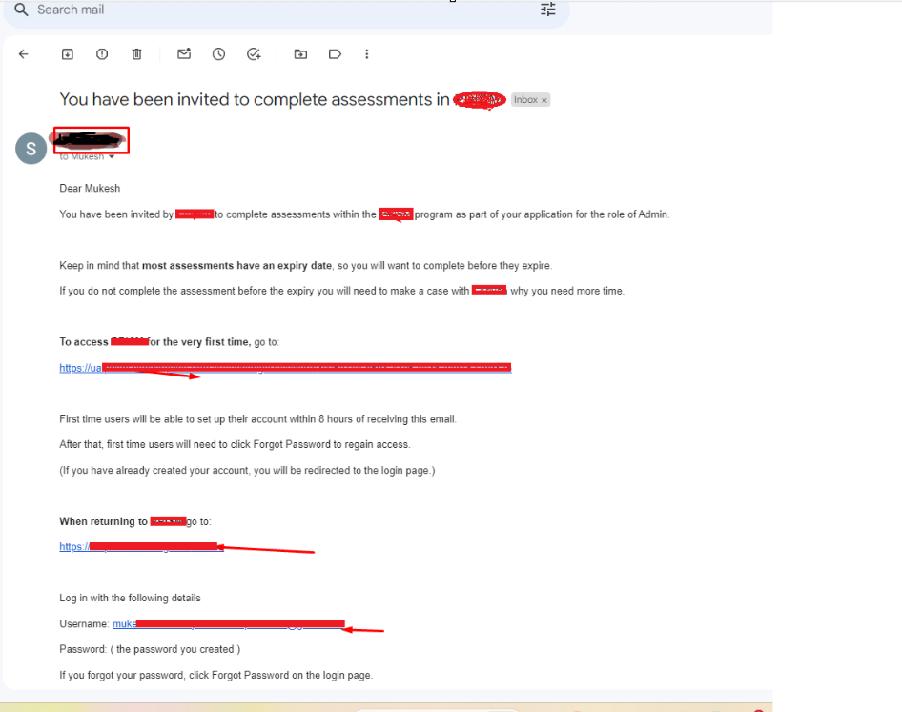

** **What we do in Backend Service** **

1. Created a Configuration file that contains the necessary information required to deal with email in a json file.

2. We use ***SendGrid*** for sending the email to all candidates.

3. Creating the Database logs to maintain the candidates profile and creating the events.

4. Use webhook in the backend to show statistics of events (like status , opened, closed, subscribe, unsubscribe, etc) on Dashboard.